Custom conditions

Built-in conditions: Generic states like clickable, visible, present
Custom conditions: Specific business logic like:
- Is button red yet?
- Has progress bar reached 100%?
- Does element contain specific data?
- Is price updated correctly?
Custom conditions handle your specific application logic that Selenium doesn't cover.
How it works:
- Define a function that returns True/False
- Use it with WebDriverWait like built-in conditions
Syntax:
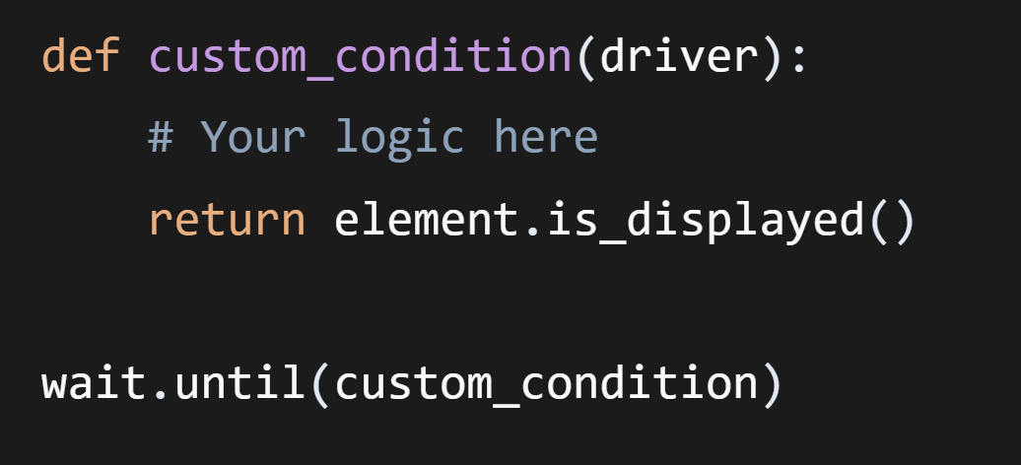
Driver is an instance of the active web browser

Important:
- Function must take driver parameter
- Return True when condition met, False otherwise
- Can combine multiple checks in one condition

